Metropolis of Denver Philoptochos
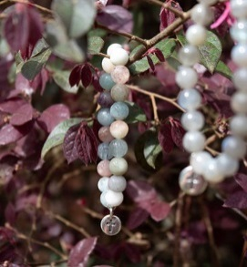
BRACELETS
Handmade bracelets created just for the Metropolis of Denver Philoptochos. Colors vary in style. $20 plus S&H

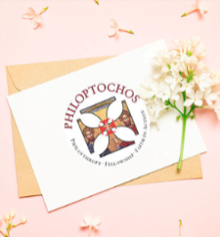
NOTECARDS
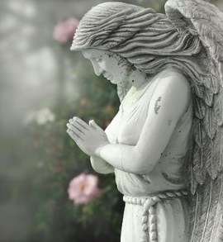
A unique bundle of 12 notecards with Philoptochos logo available. $10 plus S&H
HERE FOR YOU GRIEF PACKETS
Grief packets are available for families suffering the loss of a loved on. $30 plus S&H
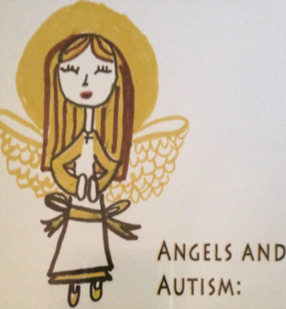

ANGELS & AUTISM DVD
This 18-minute documentary film on the spiritual life of a child with autism was produced in 2008 with the hope of enlightening the viewer of the challenges families face in their attempt to instill spirituality into their children’s lives. $5 includes S&H

 | Item Name | Quantity | Cost Per Item | Total Cost
01
02
03
04
 | Total Due: |  |  | $ .00

Name: ___________________________________________________________________
Address: _________________________________________________________________
City, State, Zip: ____________________________________________________________
Phone Number: ____________________ Email: ____________________________________
Please make Check Payable to: Metropolis of Denver Philoptochos

